FYPals

Phase 2

Team 6
Member Name | Member Roll # | Primary Responsibility
Ahmad Ali Khan | 24L-3049 | DCD, PD
Adina Saqib | 24L-3003 | SD-8b, SD-8c, SD-6a
Zuhr Faisal | 24L-3068 | SD-2a, SD-2b, SD-2c, SD-3
Hamna Faisal | 24L-2551 | SD-6b, SD-7, SD-8a, SD-9
Bilal Kashif | 24L-3036 | SD-1a, SD-1b, SD-1c, SD-4b
Manumha Nadeem | 24L-3097 | SD-1d, SD-4a, SD-4c, SD-5

Table of Contents
1. DCD 2
2. Design Sequence Diagrams 3
2.1 Form Team 3
2.2 Send Invite to Students 4
2.3 Send Invite to Advisor 5
2.4 Drop Team Member 6
2.5 Create Post 7
2.6 Vote on Post 8
2.7 Comment on Post 9
2.8 Send Message in Chat 10
2.9 View Progress in Tab 11
2.10 Manage Progress 12
2.11 Manage Checkpoints 13
2.12 Search Platform 14
2.13 Manage Profile 15
2.14 View Profile 16
2.15 Resolve Dispute 17
2.16 Submit Deliverable 18
2.17 Give Deliverable feedback 19
2.18 Send Deadline Reminder 20
2.19 View System Records 21
3. Package Diagram 22

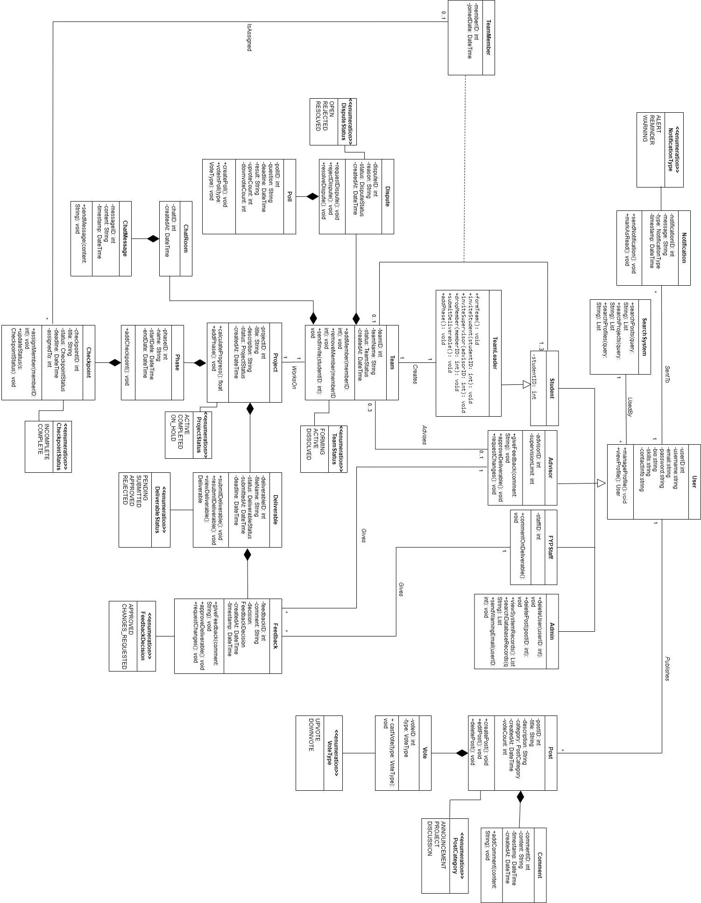
DCD

Design Sequence Diagrams

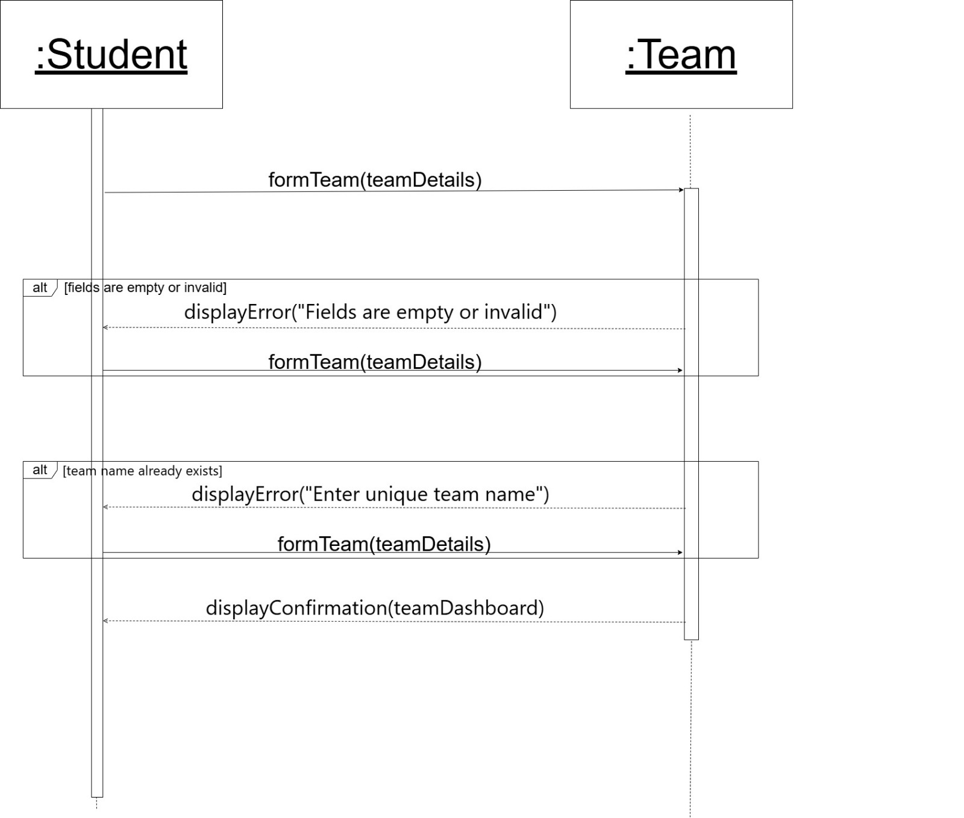
Form Team

Send Invite to Students
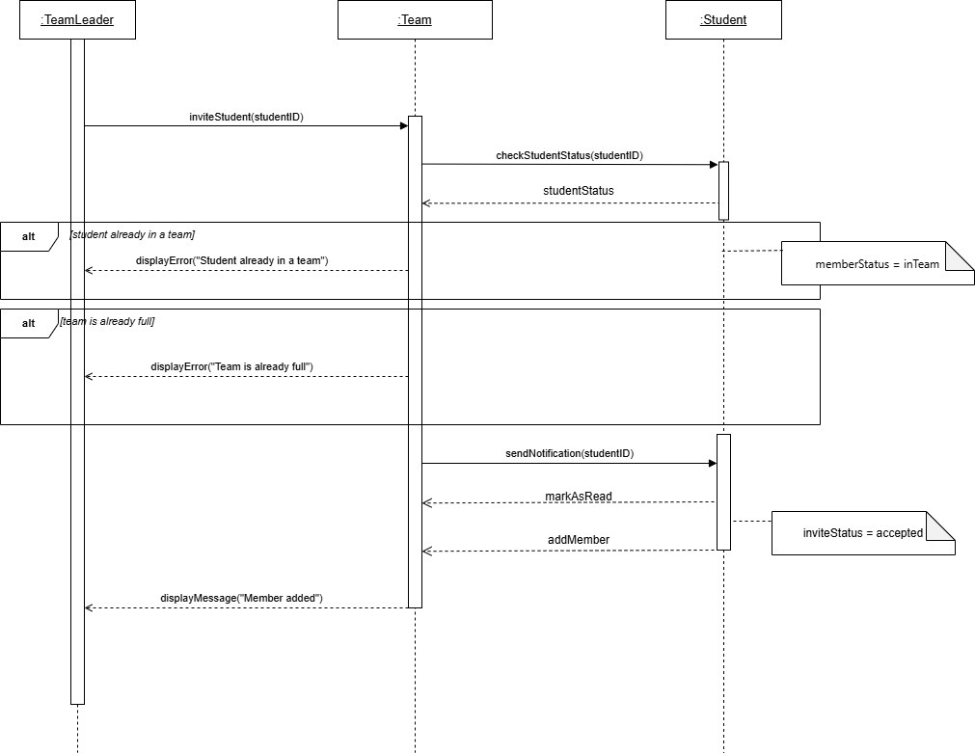

Send Invite to Advisor
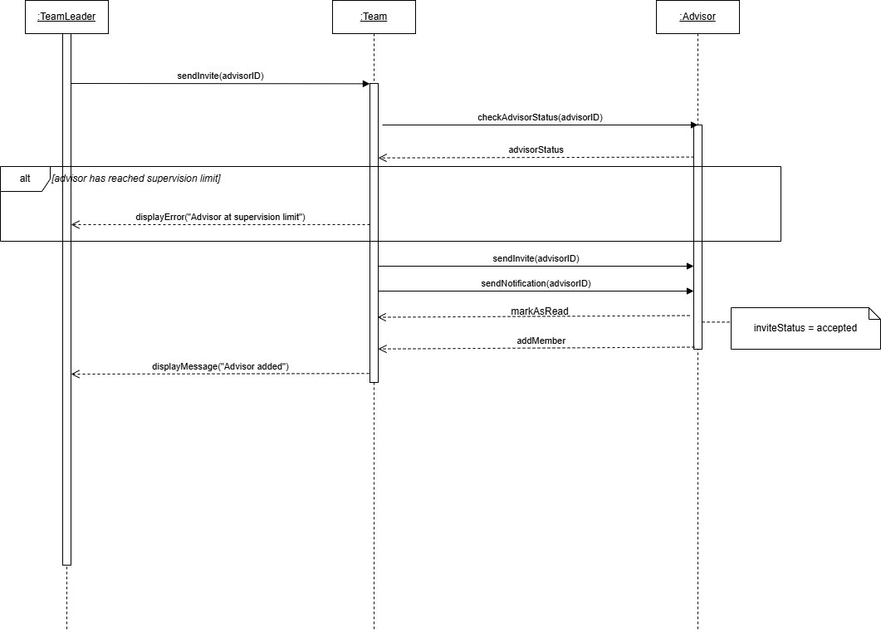

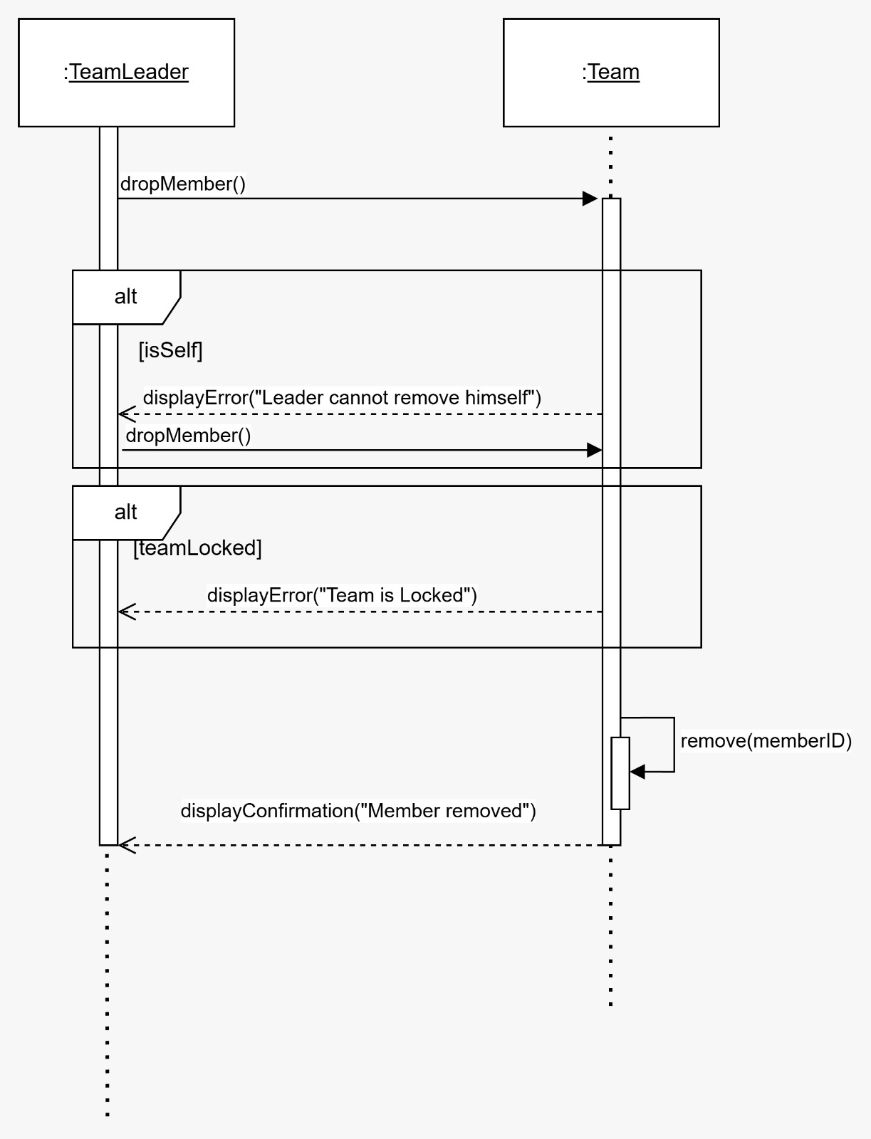
Drop Team Member

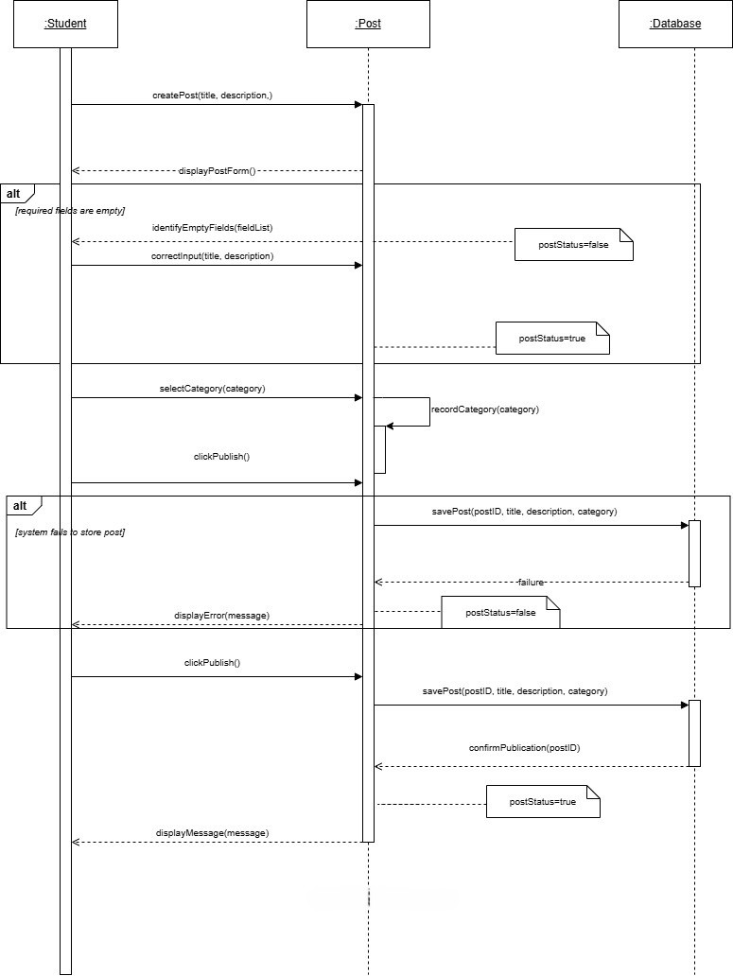
Create Post

Vote on Post
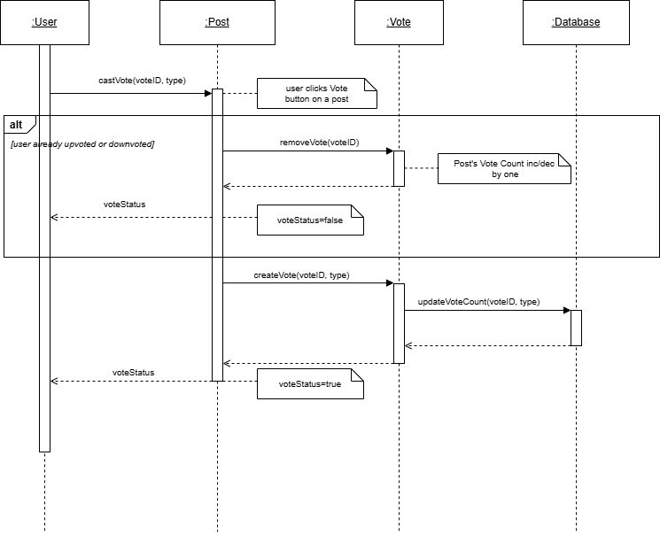

Comment on Post
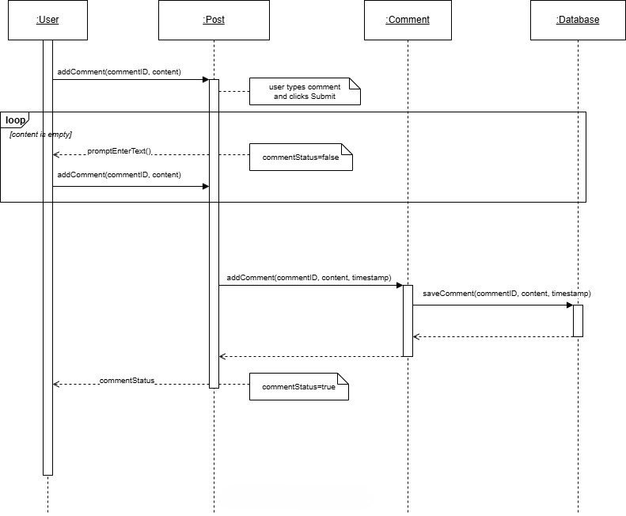

Send Message in Chat
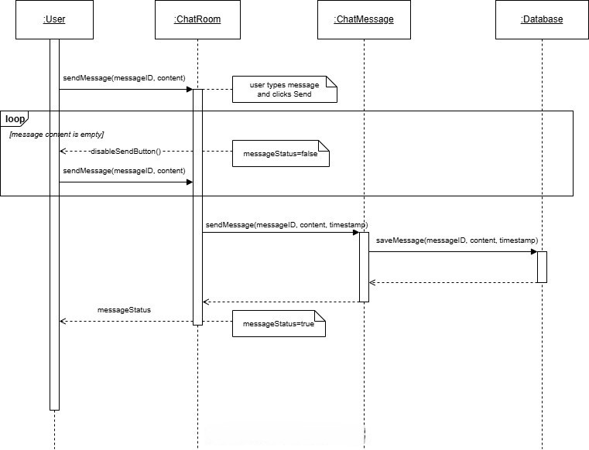

View Progress in Tab
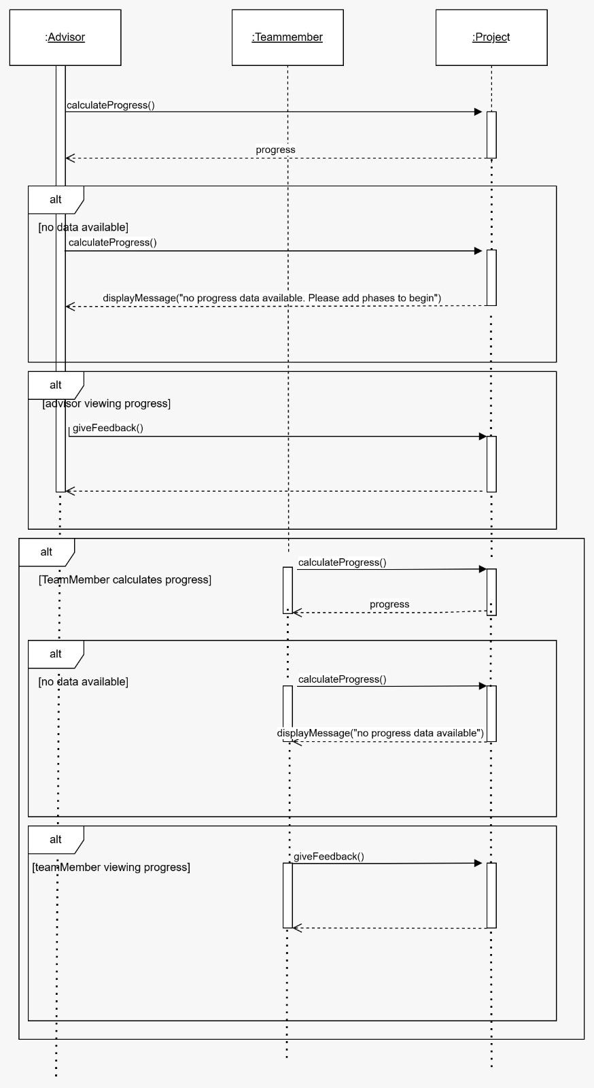

Manage Progress
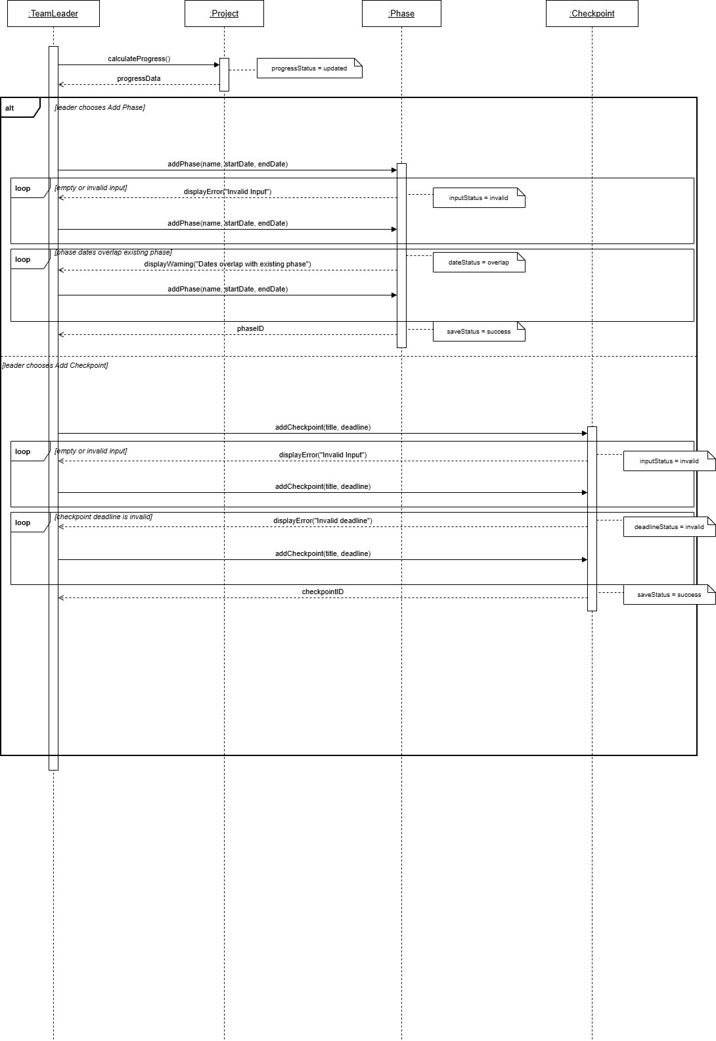

Manage Checkpoints
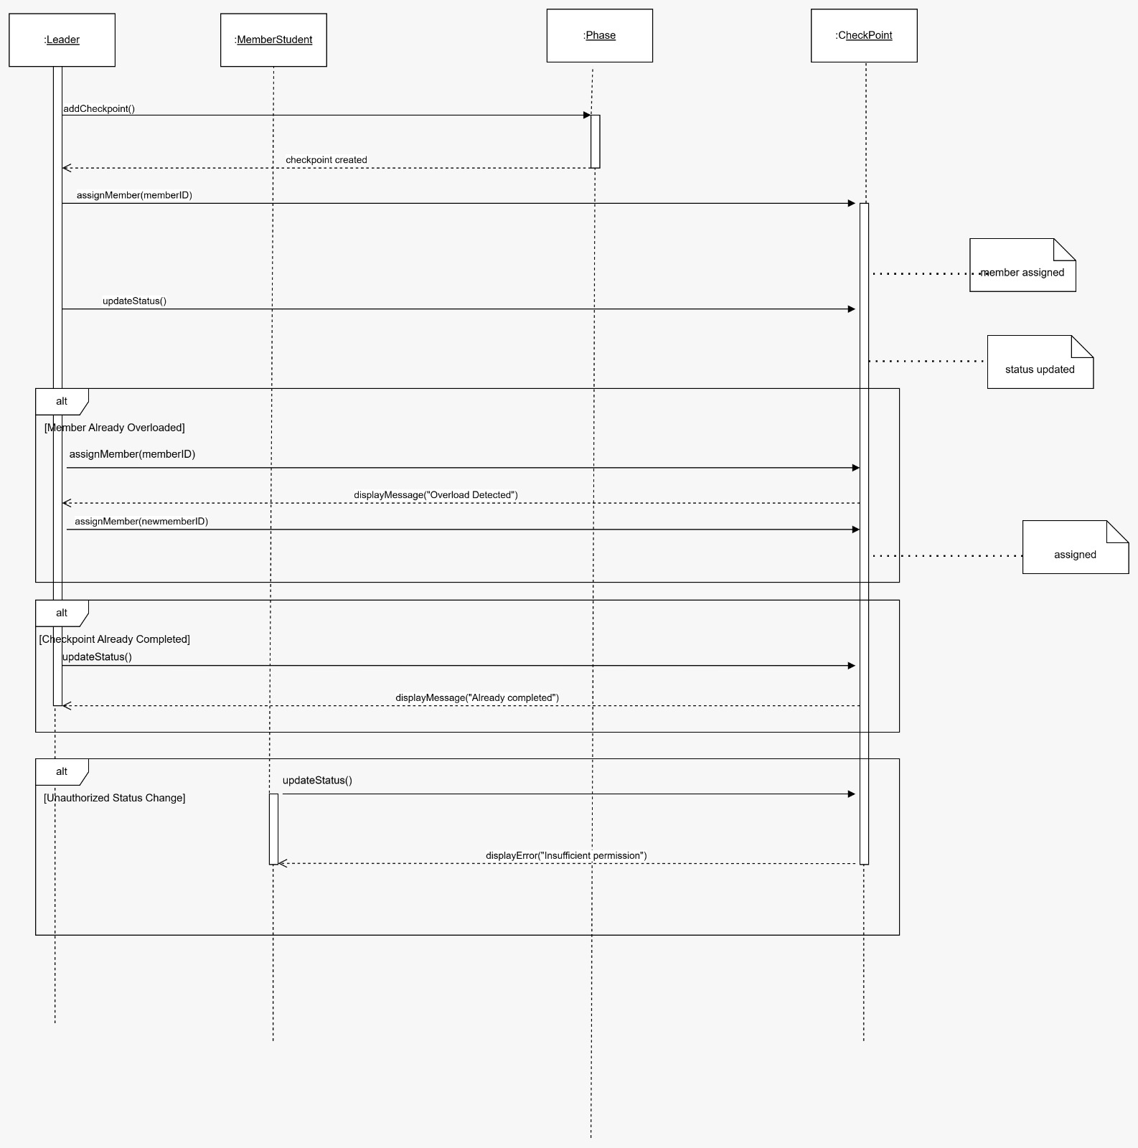

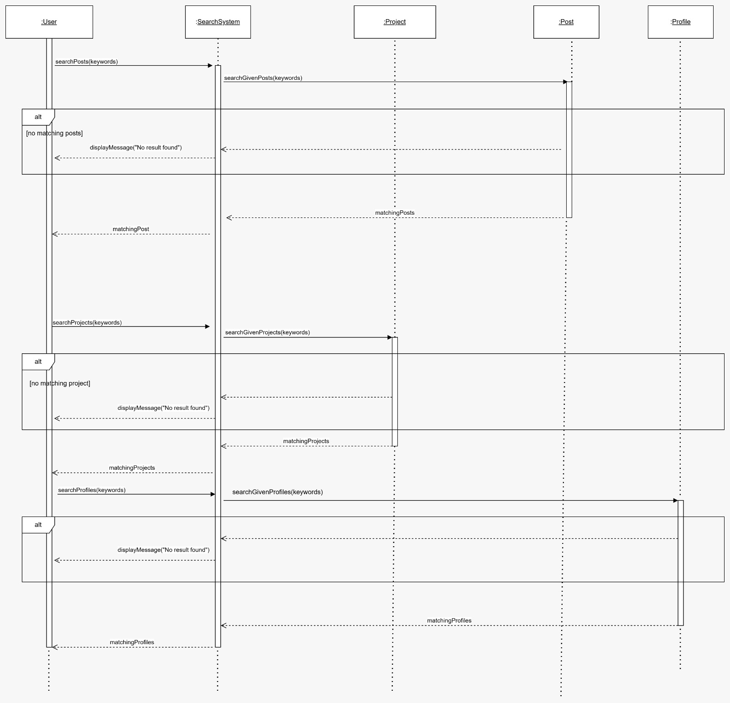
Search Platform

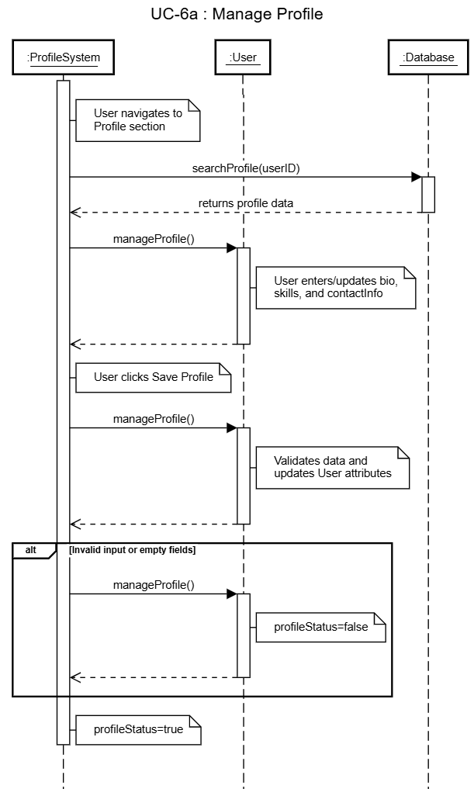
Manage Profile

View Profile
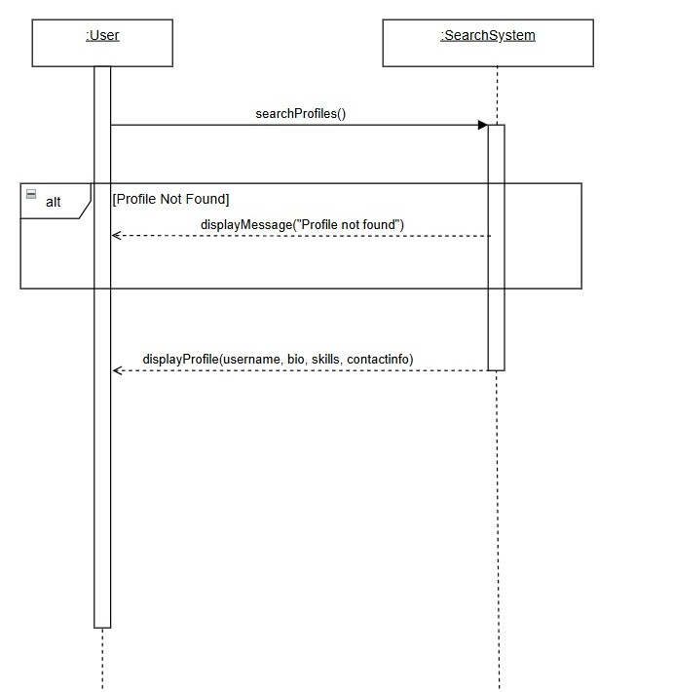

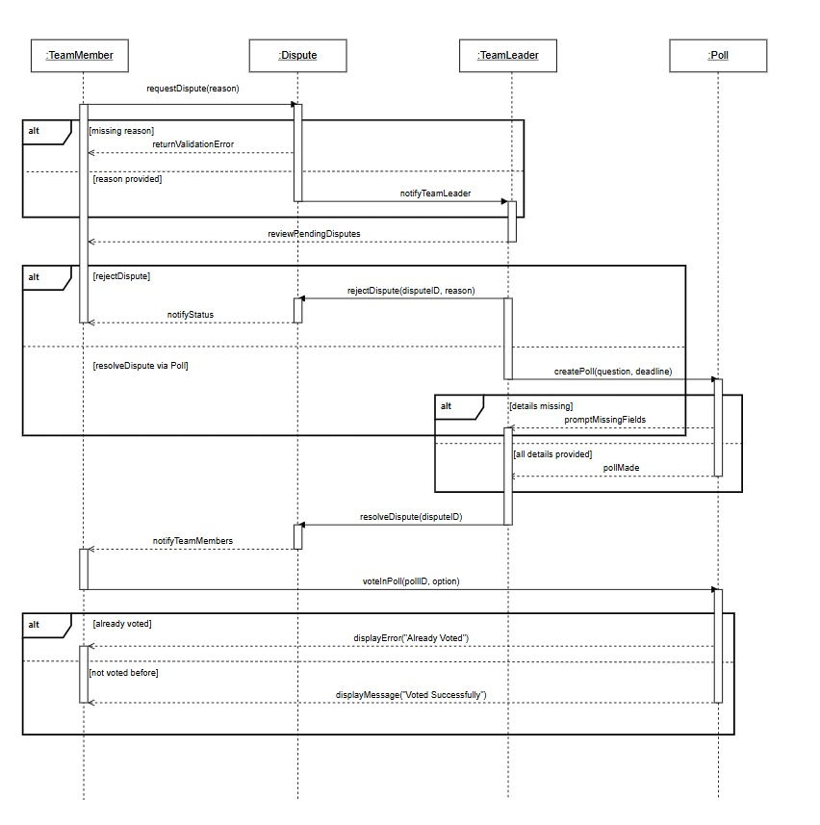
Resolve Dispute

Submit Deliverable
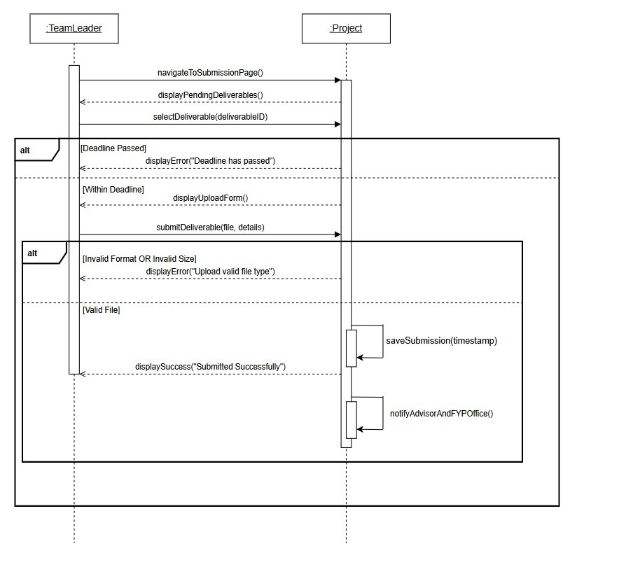

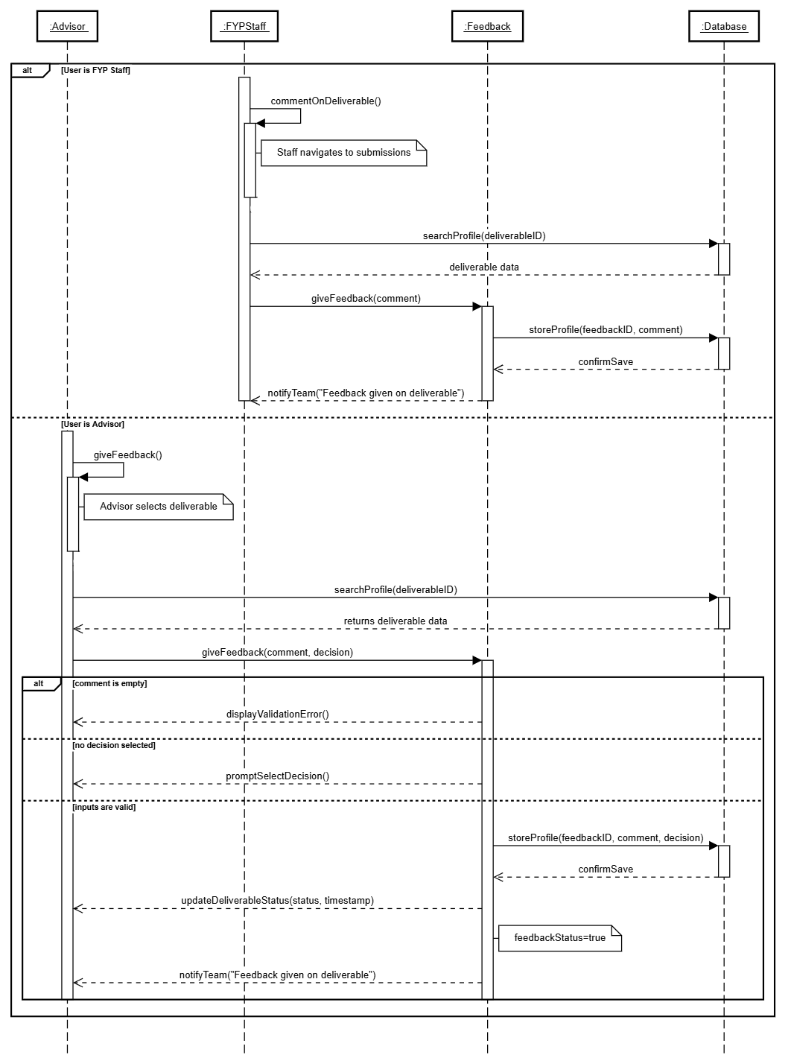
Give Deliverable feedback

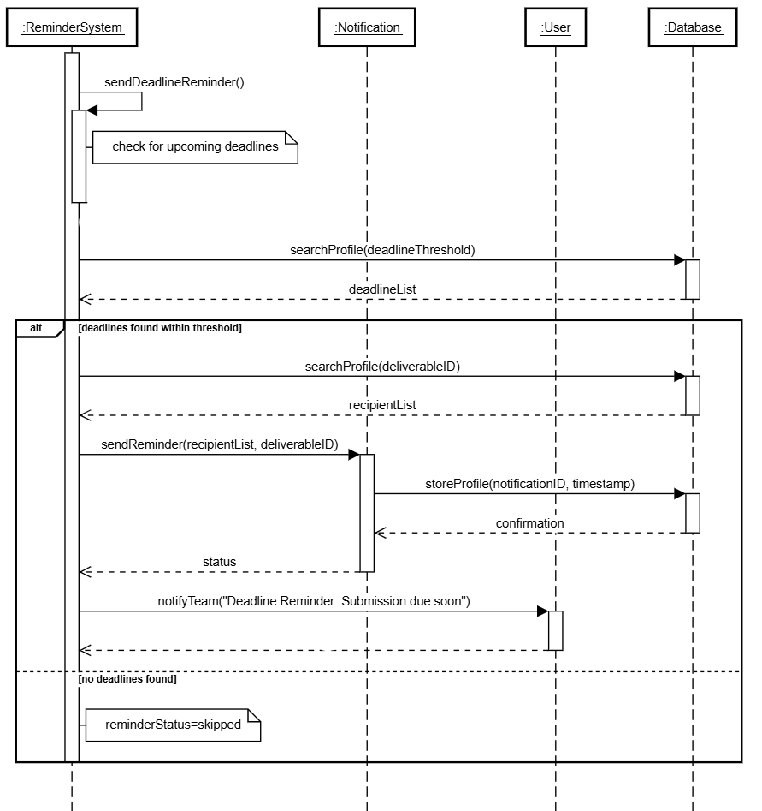
Send Deadline Reminder

View System Records
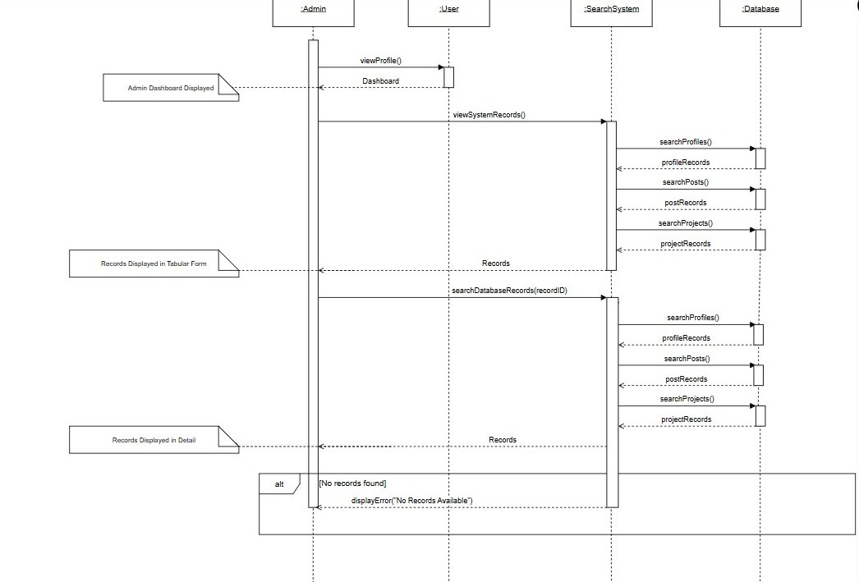

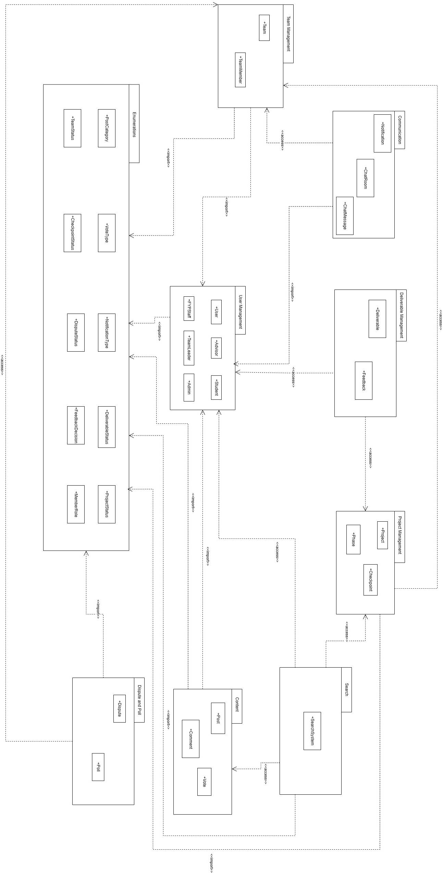
Package Diagram

